**Threadless case description**

# Introduction

Threadless is a community that supports making great art. *“All designs printed on Threadless are voted on and picked by the community. Users can submit designs to Threadless, which are then voted on for a 7 day period by other users in the community. Once the scoring period has ended, the design receives a score from 1 to 5. This is used as a gauge by Threadless to decide what gets made into a tee!”*

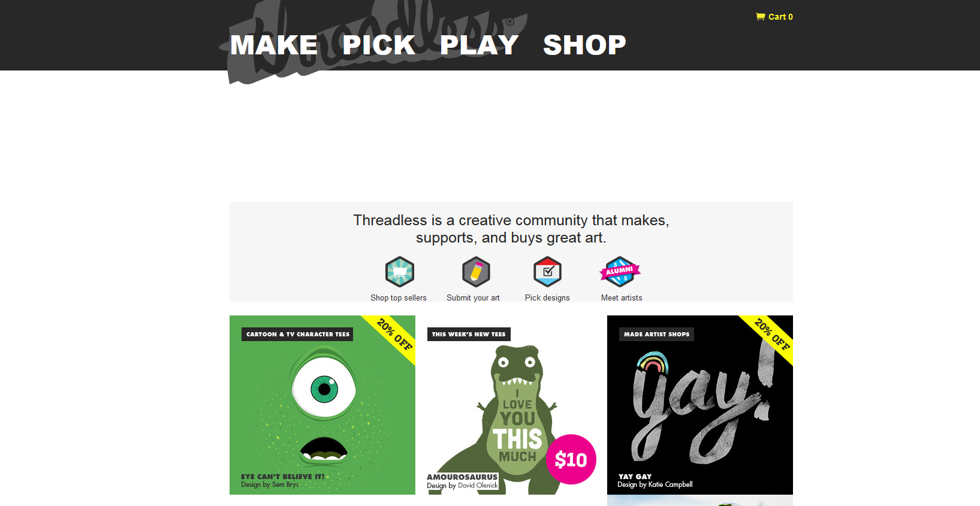

# Rules of Threadless in general

*“You are Threadless. You make the ideas, pick what we sell, you’re why we exist. When you buy from us you support great art. When you join us you support in biggest possible way. “*

“Make something cool every day”, says the founder in his TED-talk. None of the rules of Threadless are set in stone, but are changed based on what actually happens.

## Be nice

“Remember, be nice.” We take care of our people, and it’s nice working with nice people. Say somethin’ nice, reminds comments section.

Also in discussions by the users being nice is emphasized. Someone questioned why the community is nice to people who design poor quality t-shirts. Several other users pointed out that they are nice because people first, designers second, and that when people submit designs they hope people to be constructive and supportive. Community being nice to bad designers is also good business: customers are not alienated, and even the bad designers may become good designers with time and practice.

* *This is my first design using my Wacom Bamboo, please be kind ;)*

## Participate

Participate in community and help other designers to develop their skills. If you plan to design here at Threadless, you should spend some time on the forums. Give designers honest critique, but if “This is crap” is all you can muster, move on. Always try to remember to offer good advice in critique section, rather than just “neato check out mine”. There seems to be an expectation of reciprocal participation:

* *Would appreciate – and reciprocate – any constructive feedback.*
* *I have voted both your designs… could you please score my design?*

## No exploitation!

The community should not be exploited to do tasks that could easily be bought through normal channels. Translating the web site is one example that caused a mild reaction in the community:

* *You’re margins are really that tight you need a bro deal from your community?... … case to not exploit your community.*

## Stealing designs

Community & Threadless are super trustworthy. You don’t need to worry about people stealing your ideas or art. Forum discussions reveal a sort of ethics code of the community on what are allowed approaches to referencing existing art in own designs:

* *Stock images are fine to use as a base… but you definitely need to build upon them*
* *Collages from found images are totally ok as long as the images are in the public domain*
* *Tracing sections of other peoples’ work & combine is debatable – outright stealing goes against what this community is about*
* *You can’t trace with artistic intention, because that wouldn’t be a trace. Referencing and copying are not the same thing*
* *Gomedia vectors… they’re allowed. Just not likely to score well or print*
* *If a design has been printed elsewhere, it can not be subbed here*
* *Those are not rips. Seems to be same author posting to both sites long after the time restriction. They can do it.*
* *Post stolen images here so others know what to look out for!!! Also heavily influenced ones, for educated decision.*
* *I don’t understand how people think this is okay… I just… what. (copied design)*
* *People who do this should be kicked off the site (copied design)*
* *It is so disappointing to see even some talented artists trace existing images*
* *I get so annoyed when sub I scored well turns out to be stolen*

# Tasks of Threadless in general

Threadless users are expected to “make great ideas, share them with the world, earn fame and fortune. Repeat.” This ethos is reflected in a user’s instructions on how to get printed in three easy steps:

1. Draw something
2. Submit
3. Repeat. Don’t matter how good it is, don’t matter how bad it is, just don’t stop submitting

Community can be used to help with design by posting work-in-progress blogs. Once the design files are prepared according to instructions, it’s time to submit the design for scoring. To do this the user must follow the instructions and fill out the submission form (The whole thing).

# Agents and user experience

The Threadless process appears to be quite simple and straightforward. Things the user can do are nicely shown on the front page: make, pick, play or shop. Headline for commenting says “Say somethin’ nice”. People appear to be making designs fast.

I ended up having two main activities at Threadless: scoring designs and surfing around at the Forum. If I had the skills I would probably do also graphic design. It seems like a part of the reason to participate on Threadless is to improve as a graphic designer, as the following story copied from the forum illustrates:

*There comes a time in many designers' lives when they want to give up on Threadless. They are drawn in with the promise of money, and are let down when their efforts go unrewarded. It's happened to me, and I've heard others mention similar experiences. You shouldn't give up, though.*

*Being dissuaded from Threadless comes from two factors. First is taking low scores too seriously. The second is a lack of getting printed. Whatever you do, these things cannot prevent you from continuing to submit. If you get dissuaded from submitting, you'll never get printed! You need to find a way to handle these two facts: the majority of many people's designs do poorly, and the vast majority of your designs won't ever printed.*

*For me, my decision not to give up came with a transition about why I stick around Threadless. It no longer became about getting printed. It became about improving as an artist. Over the years, I've improved greatly, and this is what pushes me forward. If I submit a new design I'm proud of, I'll remain pleased with it even if it scores poorly (this is good for me, 'cause most of my subs do poorly). Now I don't worry at all about whether or not I'm going to get printed. I assume I won't, and carry on having fun making submissions regardless.*

*Keep it up! It took me 3 years and about 30 designs to get printed.*

*I asked a bunch of alumni how many designs it took them to get printed. For many, it was in the range of 20 to 30. For a few others, it was over 100. While there are people who do extremely well right at the start, there's a learning curve before you get the hang of things.*

Other users also mentioned learning and career advancement as a part of the game.

* *I mean… look at my first dozen or so designs, all terrible*
* *Many who have started here have gotten better in short time because of constructive critiques, myself included*
* *I love Threadless and I owe my career to them, but something change, not for good. If things like this keep happening I’ll probably stop submitting*

Although I cannot do graphic design, I still watched several tutorials on different design related topics. Tutorials are short YouTube videos, which appear to be mostly created by the community members. Site features also process videos demonstrating how certain designs were made.

* *Watching halftones tutorial. I don’t even know what they are. Perhaps this will be useful in Lightroom.*
* *Watching tutorial on creating brushes on Photoshop. Seems to be cool software, but doing great designs definitely requires a lot of skill*
* *Watching a process time lapse video. Cool video showing draft turn to a line drawing*
* *Watching another: time lapse Sherlock. Very artistic and skillful in my unsophisticated eyes. B&W, very detailed*
* *Watching T-Rex time lapse. Start with scanned draft. This requires skill. So many details. Drawing one hand at least 4 times*

Threadless has a staff blog. Most posts are short with lots of pictures, photos and visual material. Rough estimate is 50 % text and 50 % pictures. The blog has continuous scroll functionality and blog posts has to be opened only to read comments. Threadless has a site called Tee V, which features short video clips related to Threadless. Clips are mostly advertisement. I did not watch it much.

Threadless Forum is not massively active, as third page of the forum already has 11 hours old replies. During my observation I checked the forum regularly but did not comment very often. The forum features art and design, and promotion of designs. A few times I critiqued designs, but I found it somewhat difficult to tell the design sucks. I would describe my exploration of the forum and Threadless site as semi-random. If commentators have their own designs the platform suggests I score them, with a link.

Threadless has some visibility in social media. I started following it on Twitter, and it is possible to share designs in scoring in various social media sites.

## Community

A part of the value for the user provided by Threadless is the community of other users and designers. The community helps in design process and provides feedback and support to each other. They also organize playful challenges every now and then on the forum, such as Swapsies and ThreadDuels. These little ideas help keep Threadless fresh.

* *I’d really love to start submitting things and seeing how they do. I’d love to be part of an artist community*
* *I would love to be able to make from my art and right now Threadless seems like my “brass ring”*
* *I still don’t believe it. Really, it’s like a dream. As a t-shirt designer that’s all I ever wanted*
* *I love these little ideas that keep Threadless fresh*
* *I like this comp, great idea (Remake Swapsies)*
* *Sometime soon when I have enough designs to choose from I will def participate! Fun fun!*

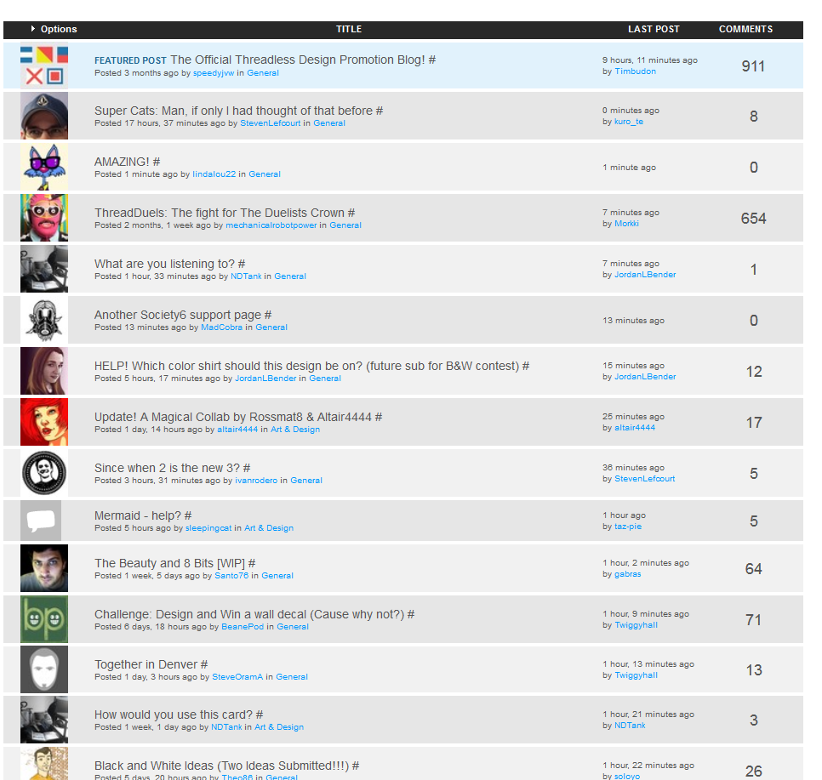

# Feedback

|  |  |  |
| --- | --- | --- |
| **Category** | **Description** | **Example** |
| Positive | Most common type of feedback. Positive encouragement for design submissions or as feedback for work in progress. Simple statements acknowledging awesomeness of designs. This kind of feedback makes the user to want to do more of the same. | This turned out great, will be giving it a $5 when its up!  Wow! Awesome! :)  $5! |
| Negative | Negative statements of designs or behavior. Aim at stopping someone doing something. | And god those eyes are terrible  If you have to bump your own threads, that’s when you know you’re onto an idea which sucks  No, it’s not an oxymoron anyway |
| Constructive & suggestions | Constructive criticism for design and tips and suggestions on how to improve it. | Your second tshirt mockup looks way better than the first… Experiment with increasing size on topmost notes reduce size of flower  Try without the white circle, it would looks more naturally I suppose  I think rev 2 is ready to submit |
| Voting as feedback | Scores from voting are visible after the voting period ends. Can be used as a form of feedback, helping the designers to gauge how much the community liked the design. | Need votes need votes need votes need votes…  I currently had 139 people rate it  FYI: mine finished scoring with 2.82 |
| Congratulations | Both official and from other users | Congrats!!  You’ve each won a Threadless pillow!  Nice job artists! |
| Thanks | Acknowledging favors others have done | Thanks guys :)  Thanks so much for the input, guys!  Ok thanks, I’ll work on this! |
| Sales feedback | Feedback and comments on products for sale. | Make a v neck please!!!  Amazingly cool idea, and beautiful design! Also as a wall print |
| Feedback requests | Requests for feedback and help on improving design work in progress | Check out my design I need some tips  Please take a look at my design and give me some feedback |
| Platform feedback | Automatically generated statistics and messages from the platform that give feedback to user on her actions. | You’ve scored all the designs in the running. Now go find something else to do!  I have 52 designs left to score  Stats |

Many of the treads on the Threadless Forum seem to be about asking for feedback and critique. Feedback from community appears to be an important part of the design process for many designers: “Before I start finalizing the design, I always get feedback from several people” (presumably including the Threadless Forum). People are expected to be honest with their feedback, but also to remember to show some tact if the designers’ have put a lot of work into it. Sometimes the feedback can be harsh, but it is at least a few user’s opinion that it’s up to receiver to make the feedback ‘constructive’ by doing something with it. If you can’t take people being mean or brutally bringing down your designs you are in the wrong field or hobby. Opinions appear to be somewhat split on this issue, as some users emphasize the need to be nice even for the crappy designers. Overall the main purpose of the feedback appears to be helping people to develop as designers.

* *Hey mind it… It’s great to see that you take these feedback positively… U are def on the right direction…improve illustration, base it on strong concept*

# Threadless innovation process

In a nutshell, the steps in the process are

1. Get your idea ready to submit
2. Submit to the challenge
3. The community scores your design
4. If your design gets printed you’ll get… <prizes>

The Make section of the site is organized roughly according to this process

* 1. *Start with an idea*
  2. *Make it better*
  3. *Submit your design*
  4. *Make more*

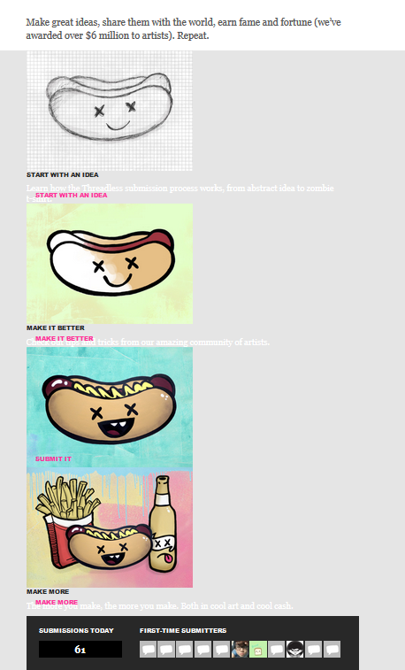

## Challenges

Threadless hosts themed challenges to inspire artists to create designs they might not have thought otherwise. Often a partner joins the fun and awards the chosen designer cool swag in addition to the cash prize.

*YOUR CHALLENGE*

*Create a super cat design.*

*Laser cats. Ninja cats. Cats with beards. Unicycle-riding cats. These are just a few of the many skilled and talented cats that call Threadless t-shirts across the world home.*

*But there’s always room for one more super cat in your t-shirt family. Especially when that tee can help prevent cruelty to animals. In honor of Adopt a Shelter Cat month, we’re challenging you to design super cat tee.*

*You can submit a design featuring a cat with amazing superhero powers. Or, you can create a cat supervillain t-shirt that’ll make dogs quiver in their paws.*

*But no ordinary cats, please. Because we need a super cat tee to do super work for animals throughout the United States. Threadless is proud to support ASPCA and its mission to save lives.*

*Legal stuff*

*HERE'S HOW IT WORKS*

*1 Get your idea ready to submit*

*Read our submission guidelines to learn about printing techniques, creating high resolution artwork, preparing presentation files, and following the rules! You'll also find color specifications and downloadable assets like templates and blank photos for mockups.*

*SUBMISSION GUIDELINES & ASSETS*

*2 Submit to the challenge*

*Once you've prepared your design files, it's time to submit it for scoring! Follow the instructions and fill out the form (the whole thing).*

*SUBMIT A DESIGN*

*3 The community scores your design*

*For 7 days, the Threadless community scores your design 1 to 5 and leaves comments. These scores and comments help us pick which designs to print. You're encouraged to promote your design to friends, family, and the rest of the Internet!*

*4 If your design wins this challenge, you'll get:*

* *$2,000 cash*
* *$500 Threadless.com gift code*
* *Two (2) tickets to ASPCA's annual Young Friends benefit event in October and a tour of their shelter (travel and lodging are not included)*
* *A diamond, cat-shaped necklace from ASPCA's Tender Voices jewelry collection*
* *A cat pillow from the PBTeen collection*
* *Super hip DJ cat scratching pad*

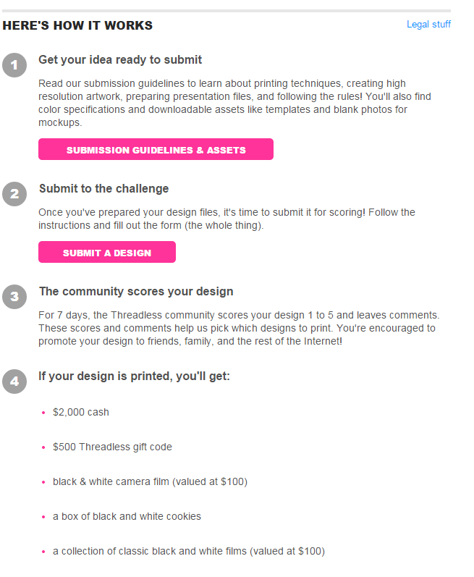

### Rules

Challenges often have themes that vary from artistic styles to current topics. Some examples of challenges are described in table 2.

|  |  |  |
| --- | --- | --- |
| **Challenge** | **Task** | **Rules** |
| Threadless | Your challenge: Submit a design to Threadless | You are Threadless. You make the ideas, you pick what we sell, you’re why we exist.  And the whole dang process starts right here. With your idea. Think you’ve got a show stopper up in that noggin of yours? Well pull it out of there and submit it!  Check out the steps below to submit a design for all kinds of products! (Bonus points for presenting your design on more than one type of product!)  The Threadless challenge is our big, ongoing, challenge. All the rest have themes, timelines, and different stuff up for grabs. |
| College! | Design a t-shirt inspired by one of 15 universities. | Your assignment is to create an original t-shirt design that represents one of the colleges listed above. If your design receives an A+, you could win $2500. Whether you’re a current student, alum, or just a college sports fan, get creative with your favorite school's signature colors, logo, mascot, school song, or anything else that triggers your school pride. Go ahead, give it the old college try!  Learn more and submit. |
| Onion | Create a design inspired by one of The Onion’s headlines. | And now’s your chance to win a major award in the form of cash and other swag by designing a t-shirt inspired by any headline on theonion.com. Your design can be word-free, as long as it’s an interpretation of one of The Onion's headlines. Be sure to mention which headline inspired you in the “about your design” section of your submission.  Visit the challenge page to review the prizing and submit your design.  If you think you've found a headline on The Onion and want to share it with an artist, post it below! |
| B&W | Submit a black & white tee design!  Check out the prizing & submit | The rules are quite simple. Use black and white only in your design. You can crosshatch and halftone until you’re blue* in the face but gray is not allowed!  *no blue either, of course. |
| Oxymorons | Create an oxymoron themed design | f you’re absolutely unsure or clearly confused, oxymoron is a figure of speech in which two contradictory words appear in tandem.  Whether you’re an advanced beginner or an amateur expert, we want your properly ridiculous, straight up twisted, or weirdly normal designs to create a new classic for one of our tees. Bring a lighthearted darkness to holy hell, or give us your seriously funny interpretation of the living dead. Make it pretty ugly or terribly beautiful—the possibilities are endlessly limited (or limitedly endless…same difference).  Legal stuff |
| Baseball tees | Submit a design for a baseball tee | There’s a reason there are no shirtless Joes in baseball, because baseball tees are so frickin’ sweet! Pitch a design for a baseball tee worthy of babes and ball boys alike. Baseball may have nine innings, but baseball tee sleeves have three quarters, so consider that shape in your design. Avoid design fouls, and make sure to use a max of two colors. If the Cubs and the Yankees can sport two colors in style, that’s all you’ll need for a blowout. If you make it, they will vote.  Your design does not have to be baseball themed. It can be anything you’d like.  Legal stuff |
| Simple designs | Submit a simple design | Create a tee with a simple design.  You know the old saying:  Simplify. Simplify. Simplify.  Let’s uncomplicate things. Use bold colors to make the simplest design you can. Your design can be clever, funny, or just plain pretty. Use a maximum of 3 colors. Simple doesn’t have to mean straight up vector objects. Texture is welcome! It could be something like Pandas for Peace or even a design like Doom Regatta.  That’s it. Simple, right? |
| Bats | Create t-shirt design inspired by bats  Check out prizes | Your challenge is to create a t-shirt design inspired by bats.  Go batty designing for the little guys because you could help save their lives. 25% of the sale of each tee will go to Bat Conservation International's efforts to help these furry creatures of the night fight the good fight. Bring to life your love of bats in any way you can imagine. Your design can be spooky, funny, creepy, or scary  Check out this incredible prizing provided by Threadless, Bat Conservation International & Bacardi+  $750 cash  $250 Threadless gift certificate  Two VIP passes to the Austin City Limits Music Festival from October 12-14, 2012  Airfare voucher up to $1,000 to Austin, Texas to attend the festival  Lodging for two in Austin, Texas during the festival  Two autographed Girl Talk t-shirts  So get started already. Stay up all night if you have to. The bats need you! |
| Button down shirt patterns | Design a pattern for a button down shirt  Download kit + submit perfect pattern | We’re getting a little fancy around here. Join us, won’t you?  Download the new Button Down Shirt sub kit and submit the perfect pattern to Threadless Loves Patterns.  We’re currently looking for patterns for next spring, so submit something on the double!  (Don’t worry if you don’t think of something until later. Button Down Shirts will be a permanent option for Patterns submissions. So, it’s OK to be fashionably late.)  Leah & Ross pulled together some inspiration for you guys for the upcoming spring season. Check out their mood boards for ladies and gents. |
| Threadless + Gap Kids | Create a Threadless + Gap kids T-shirt design | Your challenge is to create a Threadless + Gap Kids t-shirt design.  Think of an idea that'll bring smiles to both kids and kids at heart, no matter how many years young they are. The designs from this challenge will be released on Threadless + Gap kids, toddler, and baby tees and will be sold in select Gap stores and on Gap.com.  So sharpen every crayon in the box, and get to work creating your most colorful kid-friendly design yet!  One lucky designer will receive $5,000 cash. |
| Toy Story | Create a t-shirt inspired by Toy Story | So reach for the sky, and design a t-shirt so out of this world, it’ll take anyone who wears it to infinity . . . and beyond!  Keep in mind: - Characters not original to Toy Story (Barbie, Ken, Mr. Potato Head) can only be used along with other characters. - Don’t you just love Jessie’s cowhide chaps? Us too, so try not to alter characters’ costumes. - Keep it clean, kiddo! No adult references (sex, drugs, alcohol, violence, profanity, gambling, etc.) allowed.  Up for grabs: - $5,000 cash - Buzz Lightyear collectible statue - Buzz Lightyear talking action figure - Toy Story poster art - Toy Story character illustrated by a Disney Character Artist - Toy Story throw blanket - Toy Story tin lunch box - Toy Story tumbler |
| Arcade Fire | Design a t-shirt inspired by the music of Arcade Fire | Think about what makes Arcade Fire who they are and design the perfect tee for fans everywhere.  What's more, 25% of sales from the winning design will go to Partners In Health - The international organization devoted to bringing high quality health care to the world's poorest in Haiti and 10 countries around the globe.  Submit now! |
| Bow Truss Coffee | Create a design for Bow Truss Coffee Threadless blend bags | In Chicago, Bow Truss Coffee Roasters recently opened it roasting and coffeeshop doors with the mission to serve classy coffee to cool people. This challenge is your chance to see your artwork on bags of the Threadless Specialty Blend, a heavier body coffee blend originating from Colombia and Mexico with notes of cherry, dark chocolate, and peach.  Bow Truss will serve the Threadless Specialty Blend at their Chicago coffeehouse and add it to the lineup of coffee blends available for sale worldwide on their site. There are no color restrictions on your design. Your can create a design for the entire bag, but keep in mind a sticker goes on the front. So download the template, pour yourself a cup of coffee, and get started! |
| Thorn | Your challenge: Design a tee to inspire a safer online world for kids | By creating a design for this challenge, you can help raise awareness for the organization’s mission to make the web safer place for kids. 25% of net sales from the winning tee will benefit the organization.  Take inspiration from how we can be better digital defenders for children who can’t defend themselves. Create a hopeful design about a predator-free future where kids can just be kids, both online and offline. |
| Super Cats | Your challenge: Create a super cat design | Create a super cat design.  Laser cats. Ninja cats. Cats with beards. Unicycle-riding cats. These are just a few of the many skilled and talented cats that call Threadless t-shirts across the world home.  But there’s always room for one more super cat in your t-shirt family. Especially when that tee can help prevent cruelty to animals. In honor of Adopt a Shelter Cat month, we’re challenging you to design super cat tee.  You can submit a design featuring a cat with amazing superhero powers. Or, you can create a cat supervillain t-shirt that’ll make dogs quiver in their paws.  But no ordinary cats, please. Because we need a super cat tee to do super work for animals throughout the United States. Threadless is proud to support ASPCA and its mission to save lives.  Legal stuff |
| Awkward | Design an awkward design and it could appear on MTV’s Awkward!  Pull out most awkward family photo for inspiration | So conjure up all the social grace and assurance you (think you) lack, and channel it into an awesome and awkward t-shirt design! Pull out your most awkward family photo for inspiration. Reminisce about the good ol’ days of braces and the horrible haircut you gave yourself once. Think very hard about an embarrassing experience you tried to forget. And get to work creating your most awkward design yet! |
| Odd couples | Create an odd couples t-shirt design  Post pairing idea below to find a designer collaborator  Check prizing & submit | Your challenge is to pick any two unrelated characters or figures and show us how they’d interact. Would they be BFF or mortal enemies? Would they fight? Hug? Compete? Quilt? You’re the only one who knows.  Make sure to obey the rules of parody in this challenge. If you’ve got a question about a certain character and whether or not we’re able to print them, ask Rachel and Dan below.  If you're not the artist type, but have a great pairing idea, post your idea below to find a designer collaborator!  Check out the prizing and submit on the challenge page. |
| Impressionism | Impressionize your own style to create a tee design that celebrates impressionism and fashion with a modern spin | At Threadless, we like to think we know a thing or two about the fusion of fashion and art, and we’ve got a design challenge almost too haute to handle. Impressionize your own style to create a tee design that celebrates Impressionism and fashion with a modern spin. Bring your own original design aesthetic to this challenge while paying tribute to what Impressionism has done for the future of fashion, art, and the modern world.  NOTE: Please no parodies of famous Impressionist paintings, please. Be original.  Threadless is proud to support the Art Institute of Chicago’s mission to collect, preserve, and interpret great works of art for visitors from around the globe. |
| Nightmare Development | Design a snowboard and t-shirt to wear while riding it! | Your challenge is create a design for the top of a snowboard and a t-shirt to wear while riding it! Use the same design for both, or create two complementary designs. There are no restrictions or color limits for your snowboard design. The wilder, the crazier, and the gnarlier, the better! Plus, you can customize part of your board using the tips and tails in the sub kit, or you can design the shape of the tip and tail yourself. And if your design is chosen, we’ll fly you out to Summit City, Colorado this November to help build your own board from start to finish at Nightmare Headquarters.  The chosen snowboard will be sold by Nightmare Development, and we’ll sell the chosen t-shirt on Threadless.com.  Check out the challenge page and get started!  Up for grabs: - Either $2,000 cash or a trip to the Nightmare Snowboard Cooperative in Summit City, Colorado this - November (round-trip flight and lodging up to $2,000). There, you’ll help build and be a part of a - Threadless video starring your snowboard. - Your Threadless + Nightmare snowboard - Your Threadless + Nightmare tee |
| Flaming Lips | Design a t-shirt inspired by the music of the Flaming Lips  Visit the challenge page | Channel the mind-bending trip that is The Flaming Lips to create a weird, wonderful t-shirt design.  Take cues from the sunny optimism of “Do You Realize?” and “Race for the Prize,” the immersive shadows of The Terror, or the acid-streaked elements of their legendary live shows to design a tee worthy of Wayne & co. You can use an existing Flaming Lips logo, no logo at all, or get creative and make your own.  Be fearless, freaked out, absurd—anything but conventional.  Visit the challenge page. |
| Cross-cultural pattern for Fall 2014 Select | Your challenge: Design a cross-cultural pattern for the fall select 2014 collection | Your challenge is to create a pattern that combines different cultures and periods in time (past, present, or future). Your pattern can be a mashup of time and/or places. Remember when Marco Polo went to China? What if he landed on the coast of Cape Town instead? Or Mars? Or what if the Mayans rebuild their famous temples in the year 2054? This is your chance to blur the lines between fact and fiction and rewrite history!  If you are new to designing for Threadless Select, be sure to check out the collection to get a feel for the styles and patterns that have been chosen in the past.  We're looking specifically for patterns that include a spin on the following:  Multi-ethnic and richly textured designs/patterns  Folksy imagery & emphasis on traditional craft  Ornamental/ornate patterns  Storytelling—mythology and folklore references  Kaleidoscopic, unexpected color palettes  *Patterns need to be perfectly squared, tiled repeats with any of the following dimensions: 6x6, 12x12, 16x16, 24x24, 32x32  You can submit your pattern using any Threadless submission kit you like, just make sure to present the pattern on its own as well as on at least one garment.  Legal stuff |
| Greeting cards | Help us turn existing designs into witty greeting cards!  Check out this selection  Write clever one-liner underneath design | Aren’t the outsides and insides of greetings cards just so… blah? Let’s put an end to that. We already have great designs for outsides of cards, and we wanna see what you think would make for great insides.  Check out this selection of designs we think might be great for cards. If any of these designs evoke a funny one-liner within you, write your clever words underneath the design. You can do one, a few, or all of ‘em if you feel so inspired! The writers of our top 5 lines will win $25 Threadcash.  ﷯  Artists, you may see some of your printed and/or submitted designs in there. Don’t worry, we’d always clear everything with you if we decided to print some of these on greeting cards.  Get your ideas in by 5/17/2013. If we print a card with your one-liner, you’ll be compensated on the card.  Commence wittiness. |
| Original photography | Design a tee using your original photography | Design a tee using your original photography.  Photo fiends and lens lovers, it's time to show us what you've got! Use your original photography to create a tee design. The content is up to you! Snap taco still lifes, city skylines, people wearing life-like moose masks, rare flowers, or whatever makes you happy.  You can modify your photos in any way you see fit to make it the best possible design for the tee canvas.  Ready, set, click!  Up for grabs:$2,000 cash $500 Threadless gift certificate (can be redeemed for $200 cash) $250 CanvasPop gift certificate a Polaroid Z340 + print paper - about a $500 value! |

Threadless also offers challenges on creating slogans for t-shirts, but these are in a minor role and are increasingly merged to t-shirt challenges. At one point there was a new slogan system in the development, with the following rules:

* *Submission limits*
* *Show trending*
* *Second round: tweet slogan (automatically?)*
* *Highest scoring retweeted by Threadless*
* *Ability to flag slogans seen on other sites, threshold approach*
* *Flags & checks to make sure the right submitter is rewarded*
* *All slogans archived*
* *Resubmission possible, uses 1-per-day*

### Deadlines

Most challenges, apart from the constantly running main Threadless challenge, have time limits before which the submissions have to be made. Typically challenges last for a few weeks. Slogan submissions have a limit of only one slogan per user in a 24 hour period to minimize the impact of random junk submitters.

### Funny competitions

In addition to design challenges Threadless also features playful competitions for fun, such as ducks in a pool lottery, product giveaways, made-up holidays and pumpkin carving contests. These competitions may involve social media visibility, such as posting comments to Facebook or photos to Instagram of Twitter. Winners are often selected at random and typical prices are $25-50 gift cards to Threadless. For example, in pumpkin carving contest users have to turn archived design to pumpkin carving. Painting is allowed and the resemblance to original design can be exact or loose. To participate the photo of the pumpkin is then posted to Facebook contest.

### Tasks

Before making any submissions the platform offers many opportunities to learn about graphic design, user-made video tutorials on different tools and process blogs, where designers describe how they created a particular design.

* *Start with an idea. Learn how the Threadless submission process works, from abstract idea to zombie t-shirt*
* *Learning Photoshop: Experiment & try everything*
* *Make it better: Check out tips and tricks from our amazing community of artists and watch tutorials*
* *Don’t focus on getting printed, just make stuff & enjoy*
* *“Make something cool every day.” Make, make and make!*

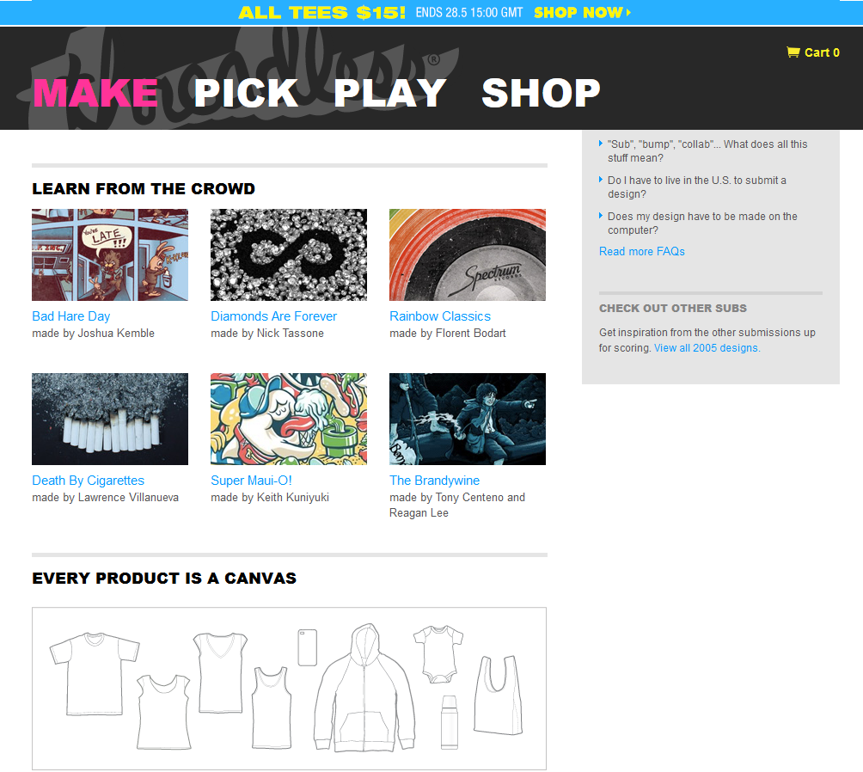

# Graphic design

Users take care of the graphic design on their own, with quite little involvement from Threadless site compared to amount of work done. During the design the site only facilitates finding collaborators and soliciting feedback from the community, neither of which is necessary for the submission of design.

## Idea

Graphic design begins with an idea. Old Threadless challenges and printed designs can be used as inspiration along the usual sources artists may use.

* *Need inspiration? Here’s every Threadless design ever*
* *Browse all 10+ years of design challenges and start thinking about what you’ll submit to the next one*
* *Check out their mood boards for ladies and gents*
* *Search for vinyl labels on the web for more inspiration*

Ideas for designs come from various sources somewhat serendipitously:

* *I think my best ideas come from nowhere about a week after my research. My brain needs a rest to come up with something useful.*
* *I use a lot of pages of my Moleskine to find an idea that can work on a tee. I check internet and books for reference after I have the concept.*
* *I’m going to develop a design from an idea I came up with while lying in bed… rather silly concept but I just like drawing so…*
* *For my design, I’m going to google search “slippers” and use some image I find there*
* *I was just trying to create something with pandas and this idea just appeared like ‘click’¨*

## Collaboration

There’s modest support for collaboration between designers. People without design skills can post their ideas to challenge comments or forum to find a willing designer to collaborate with. People use Threadless forum to search for collaboration partners, both in the early phases of the graphic design and to finalize projects when time constraints become too pressing. In renewed slogan challenge Threadless wants people to collab with artists and submit the slogan in finished design, which is then scored through normal voting process. It is possible to mention collaborators in the submission form in order to split the possible winnings. Rare efforts to offer unfair collaboration deals are met with passive aggression at the forum.

* *If you think you can’t make your idea come alive, find someone from Threadless community to collaborate with*
* *If you think you’ve found a headline on the Onion and want to share it with an artist, post it below!*
* *Looking for collab partners if you are interested email me*
* *Post an awkward story of yours below!*
* *I am also new give email can make design together*
* *I don’t have time to finish this one, so if someone have some color & design skills you can try*
* *Would you like to hear my idea and then maybe help me out and go 50/50*
* *Designer needed for oxymoron challenge!! Anyone willing to draw this to me? Split 50/50.*
* *I am so grateful I stumbled upon this offer to get a 50 % share in the project. All I have to do is make everything myself and I’ll get 50 %!*
* *Collaborators split awards and royalties evenly. All collaborators listed in submission, tags, catalog, etc.*

The Threadless community organizes occasionally playful competitions or challenges to encourage collaboration, such as Remake Swapsies, where two designers remake each other’s unprinted submissions

* *Find a partner*
* *Remake their unprinted sub, they remake yours*
* *That’s it!*
* *No deadlines, only personal timeframe*
* *Mention partners subs chosen*
* *Mention challenge & add partner as collaborator*
* *Include remake logo to avoid dumb comments*

## Sketches

The first step in materializing an idea is to make one or several sketches. The first sketch is often made by hand and then scanned to graphics software for further processing.

* *I always start with a sketch (composition)*
* *I usually draw my design by hand, and then color them with photoshop*
* *Once I’ve got the first sketch, I make yet another sketch! (More fine details)*
* *I can do 3 or even 4 sketches before final line*

The sketches are cleaned with line work, which gets the design closer to its final shape. After that comes coloring. During the work the designers often seek feedback from their friends and Threadless community.

## Drawing tools

The main tools designers use are various types on pens and paper, and graphic design software. Adobe products appear to be the most popular, especially Photoshop and Illustrator. Drawing tablets make working on computer easier. Some designs feature exotic materials, such as cigarette ash, but these are fairly rare.

* *I draw in dipping pen, scan, color in Photoshop, clean lines on Illustrator*
* *I use marker paper and Micron pens and sometimes a brush pen for coloring in bigger spaces*
* *I freehand my sketch on paper, scan it, then draw all of my images on a top layer (using mouse)*
* *I usually draw my designs by hand and then color with Photoshop*
* *I could get some hot effects out of Photoshop, but I never use it for Threadless designs. I’m total vectorhead*
* *I happen to stick exclusively to raster images & Adobe. Probably the most common choice among designers but not right for everyone*
* *For me, my tablet is like a best friend – I really don’t know what I’d do without it!*
* *Drawing with tablet can be awkward first, but it becomes second nature once you put enough time to it*

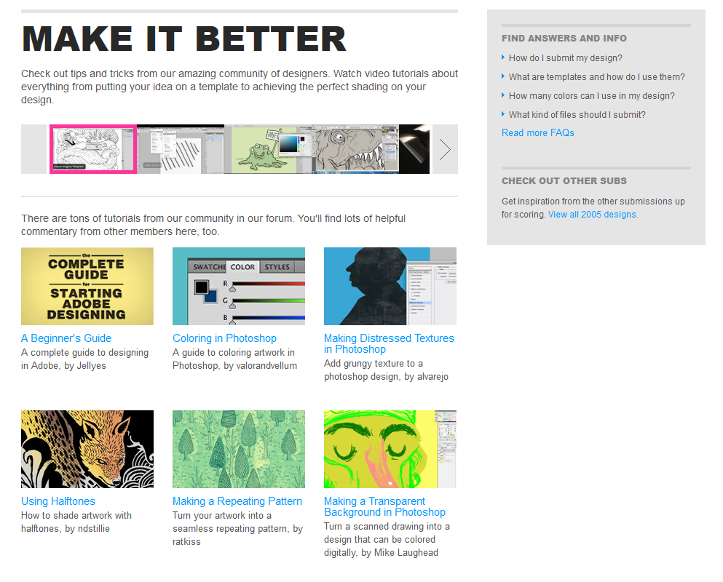

## Feedback

Designers use Threadless Forums actively to solicit feedback from the community for their work in progress designs. For many the feedback on the forums seems to be important part of the design process. Some users even start discussion threads where they offer to comment work in progress.

* *If you want some feedback on your design, then post a link to it here. I’ll try my best to give good suggestions… in order to help you improve*
* *I urgently need some critiques!! (sketch). Does it look dangerous enough?*
* *Please tell me things! (critique) I’d love to get some feedback on it. How could it become beyond awesome?*
* *Need critique! Hello community! Please comment and help me out. Should I ditch it altogether? Let’s help each other out*
* *Do you think I should go on with this or has it been done before? Thanks for your input*
* *I have 1 design up, 17 in critique and would appreciate – and reciprocate – any constructive feedback*
* *I need your help developing this idea. The title will be “Fly you fools”. Any thoughts?*
* *Please critique mine <link>*
* *I just submitted my first design… would love to get feedback*
* *Please take a look at my design and give some feedback!*
* *What do you think about this little girl*
* *Check out my design need some tips <link>*
* *I would love to know what do you people think about the concept, or the execution, or even the name*

Most of the feedback is friendly, even when pointing out issues in the design, but there are exceptions to the mean side. Opinions of the community appear to be split on mean comments as feedback. Some consider it unnecessarily rude and maintain that the community should be nice to inexperienced designers to encourage them to develop their skills, and others consider mean comments (especially from particular members of the community) almost as rites of passage. They also suggest that being able to take crushing criticism is part of the deal if one wants to do graphic design.

* *I won’t make any changes since (A) It would defeat the purpose (B) It’s already submitted (and I actually don’t give a flying fuck whether or not it’s actually printed)*
* *I really don’t understand why you feel the need to open your mouth when it comes to critiquing anyone’s work*
* *It’s the people like you that ruin the experience for the people that would probably be great at designing awesome designs*
* *I really don’t appreciate your insults toward me or anyone else on this site*
* *Having your design torn apart by a cutting barb from taz-pie is like a right of passage here. Don’t take it to heart :)*
* *If you can’t take people being mean or brutally bringing down your designs you are in the wrong field of work / hobby. [Feedback may be] rude but legit*
* *If you aren’t willing to change a design, don’t ask for feedback*
* *It’s up to receiver to make feedback constructive by doing something with it, not the giver of feedback. Giver need to be honest*
* *“Not submitting so no critique” fallacy: She’s a consumer of Threadless = target market*
* *It’s best to keep instincts to retaliate against criticism to yourself x3*

It might be that the Threadless community is not discussing designs anymore as actively as it used to, but this is very difficult to verify.

* *I don’t feel it’s cool to submit anymore… Only thing different was community, but today, not so much*
* *You don’t see people commenting anymore…it seems majority of people voting are only friends or fake friends of someone spending more time promoting than designing*

## Refinement

Based on the feedback the design is refined before submitting. Table x describes a few design processes.

|  |  |  |  |  |  |
| --- | --- | --- | --- | --- | --- |
|  | **Sketches** | **Line art** | **Coloring** | **Feedback** | **Refinement** |
| The Brandywine WIP | We began this fun project by laying my vision before him with the aid of several reference images in addition to a really, really raw concept sketch by master artist.  Tony soon returned with his reply and interpretation of my sketch | We continued to trade feedback daily and from the collage of process images, one can see how quickly this design moved forward from concept to a well-rounded near completion state in just seven days! | Soon after it was time to sample the often dreaded step â€“ colors | before relaying it out there to a few fellow artists and die-hard LOTR fans for any last minute tips and/or blessings, before final touches. | The following fortnight saw us continually refine details and add minor additions/subtractions |
| Design process description | First I sketch out a concept on regular 8.5"x11.5" plain copy paper.  Next I scan the sketch and bring it into Photoshop.  After scanning the document, I adjust the levels in PS. Next I use this great PS action found here to isolate my sketch from the white background. I then size my document accordingly  Now that I have my sketch in place, I name it my "sketch" layer. I begin to modify it by adding or deleting various elements. Basically I just play around with the design and mold it to what I want it to look like. I use a wacom tablet for this. | Next I create a new layer and label it "line art | After my line work layer is finished, I begin adding new layers to the document. The number of layers you have is determined by the number of colors in the design |  | When completed, I have a document that consists of 8 layers. 7 layers correspond to the 7 different colors and the 8th layer is the t-shirt color teal |
| Death by cigarettes | the design is made from two packs of cigarettes, although i only used a few cigarette butts. Didn't really smoke any of them (i quit smoking about 5 years ago), i just let it finish by itself and collected the ash. | added some paper cutouts to form the eyes and nose. dropped some cigarette ashes to form the outline of the skull.  The skull seemed a bit off at this point so had to tweak it a bit. Moved the nose and teeth up a bit.  changed the background to black to make it fit the shirt color. |  |  | A bit of editing in photoshop and voila! It's done! |
| Bad Hare day | Since I'm going for a more loose cartoony look I went pretty straight to pencils for this design, and added some temporary type for the bottom half | I'm going to blue line the inks to print out onto bristol board. <details> Once I've printed out my bluelines, I go to inking, using 005, 01, 05, and 08 microns, and my pentel pocket brush pen.  At this point, I scan in my bristol board: I then clean up and separate my ink layer from the white page | Coloring. I pick a shirt color from threadless, and color my background layer based on that. Then I make a new middle layer, which I use to paint on the flat colors |  | Texturing and halftoning |
| Wrong Forest WIP | Here's my rough drawing for the forest creatures competition. I figured I would make this a largely community based design and I'll show my step by step progress. Let me know how it can be improved. | Started the line work on Forrest. I'm new to Illustrator so it's taking me FOREVER... And I don't particularly like the eyes. Any suggestions?  I have no idea what I should do for the background. I kind of want to do some sort of scenery without using any black outlines. Any ideas?I'm also looking for whatever you guys think would make this look better in general. Thanks in advance! |  | Yep I'm definitely liking it more now. Thanks for all the suggestions, and I would love more. The grass is kind of temporary to see how I like it. I'll add a few more animals tomorrow. I also need some advice for shading. | I've added some detail and a bit of shading (I'm not good at shading...) I appreciate all of the comments, and I'm incorporating them gradually  I added a couple more creatures and some more detail. |
| Diamonds are forever | I modelled the diamond shape in cinema 4d and textured it with a reflective, refracted surface. Then i put them in a huge group and multiplied them in an array (with randomness effecting it), placed them on top of modelled mobius strip:… i realized that in order for the diamonds to fall into the shape and not land on top (duh) i should make the mobius strip slanted and sloped so the diamonds went into the holes and gathered around it: | now i added dynamics to the diamonds and pressed play, simulating a fall onto the mobius:… i "baked" the frame i wanted, which takes the simulation and creates each frame, found the frame i wanted and froze it, then deleted the stencil of the mobius model: | so i had the model i wanted, now i fixed up some textures, did some test renders (which takes the wireframe and makes it a final image photo-real quality), and made some lighting: |  | so then i clicked render and watched it crank out. took about an hour and a bit for the 300 dpi version. this is kind of what it looks like when rendering:  ended up with the final version, tweaked a bit in photoshop, mocked up, threw it in phil's flash template and subbed it! |
| The Rainbow | First of all I scanned a Vinyl (600 dpi). That one was Scarlatti's "32 Harpishord Sonatas" | I played on the levels on Photoshop to have a sharp and contrasted picture of the grooves. By using the tool "Color range", I isolated only the black stripes of the picture. I Used "Color Overlay" to make it completly white.  I drew the 6 stripes and colorized them with vintage rainbow colors. I putted the white grooves layer on the stripes ( see the animated gif bellow)  I took some pictures of the sky on a cloudy day. Desaturation on Photoshop, and then I used the same technique as for the grooves: "Color Range" with White . Then I organised the cloud pictures to hide the whole bottom of the design to make the Lp fly. I also added some clouds with a created PhotI scanned a blank white Lp label(600 dpi) . Corected the levels to have a great contrasted label, and added distressed textures.  Now I wanted to make it look like a vintage label so I had to create some fake companies logososhop brush. |  |  | I added some details as "Stereo" or the copyright infos, and added some birds flying through the clouds. Every text and logos on this label were textured manually with the eraser tool.  4. FINAL RENDER (FIRST VERSION) |
| Design process | I always start with a sketch. It helps me figure out the composition of the piece and where the elements stand in relation to one another. Once I've got the first sketch done, I make yet another sketch! In this sketch, I include more fine details | Since my last sketch is so detailed, this step is usually pretty quick. I just go over all of the lines with black. This is also why pressure sensitivity is so nice. Varying your line width makes your lines look interesting and more alive than if you draw with a constant line width. Try it out on your design and see what you think. | Once that's done, it's time to add color. I always start by selecting the color of the shirt. Using the Threadless tee template pack, I select a shirt color that seems to work best for the design. | Before I start finalizing the design, though, I always get feedback. People are friendly here -- they like to help out when they can. You don't want to nearly finish a design only to be told it'd look better if it was a little different (this has happened to me before). | I apply the color until the design is complete. I put highlights, shadows, and that sort of thing in. While working, I asked for feedback multiple times. In the end, I got this:  I've made a bunch of changes to the design since the 'final lines' I did earlier  Preparing Your Submission |
| Windy WIP | First sketch  Second sketch  Third sketch | Rough linework  Linework cleanup | Rough colors |  |  |
| Oxymoron WIP | This is what I started with:Quick tiny pencil sketch from my notebook. lol for some reason all my doodles are super tiny. This guys only like an inch and a half tall :P | My first pen work:  Getting ready to do another go through with my good Microns and really nice 'non-bleeding' pen paper... | I'm thinking sort of a distressed palette of "faded" brights like a vintage Circus poster | Do you get it? Do I have to tell you what the Oxymoron is?Any suggestions or complaints before I move into what I hope is my final line work version so I can get it scanned cleaned up and colored? |  |
| Rabbit in headlights | Sketching in a notebook  Clipping a character from a photo, searching pictures of crashes and mashing them up  Drawing with lightboard. Some kind of sketching | Editing on computer  Adding wheels  Printing and drawing on paper  Line work, I guess  Searching for bunny pictures and compining them  Printing it as a model, then drawing a sketch  Scan, something on computer, print and line work again  Scan on computer  Working on both pictures on computer  Combining them and pasting on a template | Changing colors |  | Working on details and background |

## Submit to challenge

Submitting a design to a challenge involves preparation of final files and filling in submission form.

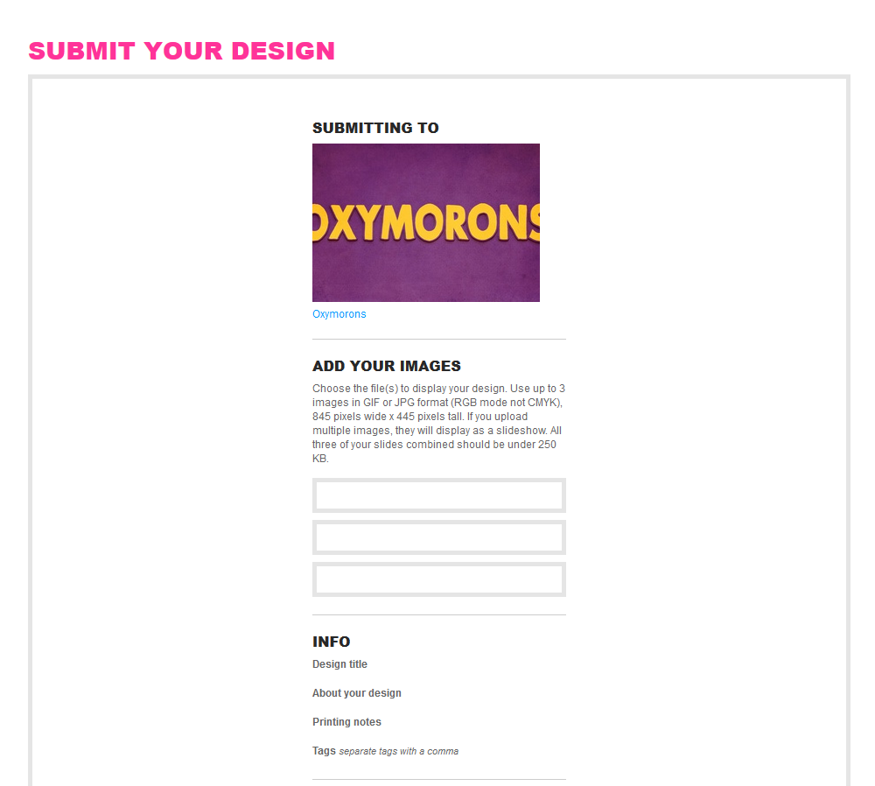

### Rules

Threadless prints art on tees, but not any style of art. The design needs to have the “Threadless feel”. On the other hand people shouldn’t try to define Threadless look but instead let new people bring whatever they want. The concept and aesthetics are important dimensions for scoring well. The concept should Invoke some thought and the nice to look at designs are scored highly. The technical submission guidelines and assets seem to be about the same for different challenges. People are encouraged to read the submission guidelines to learn about printing techniques, creating high resolution artwork, preparing presentation files and following rules. Design challenges have legal terms and conditions, which must be accepted before making a submission.

*HERE'S HOW IT WORKS*

1. *Get your idea ready to submit*

*Read our submission guidelines to learn about printing techniques, creating high resolution artwork, preparing presentation files, and following the rules! You'll also find color specifications and downloadable assets like templates and blank photos for mockups.*

*SUBMISSION GUIDELINES & ASSETS*

1. *Submit to the challenge*

*Once you've prepared your design files, it's time to submit it for scoring! Follow the instructions and fill out the form (the whole thing).*

*SUBMIT A DESIGN*

1. *The community scores your design*

*For 7 days, the Threadless community scores your design 1 to 5 and leaves comments. These scores and comments help us pick which designs to print. You're encouraged to promote your design to friends, family, and the rest of the Internet!*

1. *If your design is printed, you'll get:*

*An upfront cash payment (between $250-$2,000!) based on what it’s printed on. Royalties (3-20%) based on the number of products sold with your design!*

*SUBMISSION GUIDELINES & ASSETS*

*PREPARING YOUR DESIGN*

* *Three-slide submission example*
* *Create a high resolution version of your design. Keep your layers separate.*
* *Create a 72 dpi flattened copy of your design.*
* *Download a template of your canvas below.*
* *Drop your flattened copy onto one of these templates or create your own.*
* *Your submission should be no more than 845 pixels wide, 445 pixels tall, and 72 dpi.*
* *Save your file as a jpg.*
* *Submit up to three slides. One slide should show your design on a template. The other slides can be closeups, different canvases, or alternate color schemes. All three of your slides combined should be under 250 KB.*

*TEMPLATE DOWNLOADS*

* *T-Shirt2.1 MB zip*
* *Girly Styles983KB zip*
* *Kid Styles1.5MB zip*
* *Hoody2MB zip*
* *Crew Sweatshirt1.6MB zip*
* *Tank1.1MB zip*
* *Scarf761KB zip*
* *Messenger Bag1.5MB zip*
* *Jetpack4.2MB zip*
* *Laptop Case2.8MB zip*
* *Pencil Case2.8MB zip*
* *Wallet980KB zip*
* *Notebook1.9MB zip*
* *iPhone230KB zip*
* *Card172KB zip*
* *Wall Art2.4MB zip*

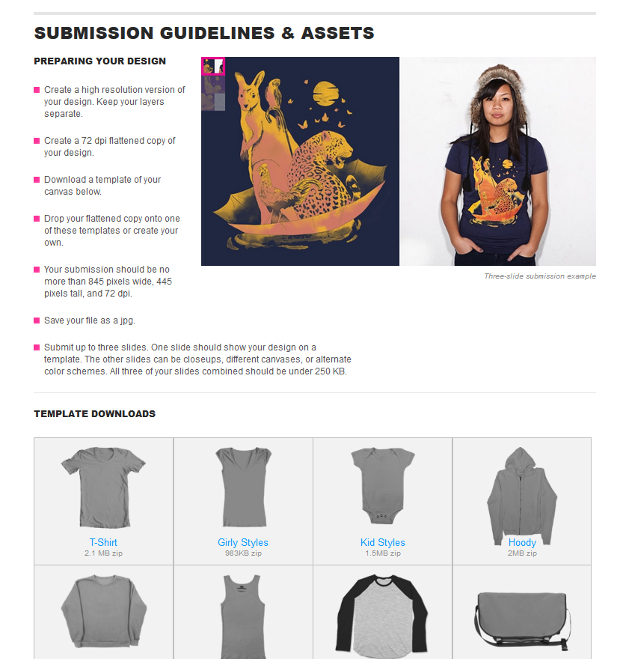

*DESIGN CHALLENGE SUBMISSION LEGAL TERMS & CONDITIONS*

*By submitting your design, and in consideration of Threadless.com evaluating your design submission (the “Design”) for its possible use, you agree to the following terms and conditions (the “Design Submission Terms and Conditions”):*

*The Design is your own original work, is not and has not been offered for sale anywhere by any means, and does not contain any trademarks, logos, copyrighted material, content subject to right of publicity or privacy, or any other intellectual property belonging to any third party.*

*The Design does not infringe any rights (including but not limited to copyright) of any third party.*

*By submitting the Design to Threadless.com you hereby grant Threadless.com the right and license to upload, modify, reproduce, copy, exhibit, create derivative works of, distribute, and display the Design, in any manner, for the purposes of promoting the Design and/or Threadless.com.*

*You may not use the Design for any commercial purpose (e.g., sell or license the Design, or offer to sell or license the Design) for ninety (90) days after the date of submission to Threadless.com. Once ninety (90) days have passed, if the Design is not chosen for print by Threadless.com, you are free to use the Design for any commercial or non-commercial purpose. Should this occur, you shall not use the Threadless.com blogs to promote the Design or the company using, displaying and/or selling the Design. You further agree not to use the Threadless.com blogs to promote the products and/or services of any company that compete, in whole or in part, with Threadless.com. Threadless.com reserves the right to choose your design after the (90) days have passed, on the condition that the design has not been used for any commercial purpose.*

*You acknowledge that Threadless.com may decline to select the Design or exclude the Design from consideration, for any reason, at any time, and in its sole discretion.*

*If the Design is selected by Threadless.com, you shall assign the entire right, title, and interest in and to the Design to skinnyCorp, LLC, which is the corporate entity that owns Threadless.com, and will waive any “moral rights” you may have in the Design.*

*You alone will be responsible for the payment of any tax that arises as a result of receiving any payment from Threadless, its subsidiaries, related companies, partners, or licensors.*

*If the Design is selected by Threadless.com, you may display the Design on a website owned and/or operated by you, and you may use and display the Design for any non-commercial purpose; however, should you wish to further display or use the Design, or use or display the design for a commercial purpose, you must first obtain written approval from Threadless.com, which may be obtained by sending an e-mail to license@threadless.com.*

*If at any time you become aware that the Design has been used, reproduced, or displayed for any commercial purpose, and/or that it has been offered for sale, sold, licensed, or assigned to a third party, you must immediately notify Threadless.com by email at art@threadless.com.*

*If you are not in compliance with any of these Design Submission Terms and Conditions, the Design may be rejected by Threadless.com, and may be excluded or otherwise deleted from Threadless.com.*

*You acknowledge that Threadless.com reserves the right to decline to select the Design for any reason, at Threadless.com’ sole discretion, and that the decisions of Threadless.com are final and binding.*

*By submitting your design you acknowledge that you have read and are comfortable with these Design Submission Terms and Conditions, you agree to be bound by them, and you wish to submit your design to Threadless.com in accordance with them.*

### Tasks

Submit a design to Threadless (or other challenge). Check out the prizing.

* *Got a design that’s polished up and ready to go? Submit it already! 6 open challenges*
* *Preview: create new document 150 dpi, 650x800 px. Scale & copy design, change background to tee color and get image of t-shirt*
* *Rules: Preview image needs to show the entire design & where it’s going to go on shirt*
* *Prepare submission: artwork on submission file, large preview + thumbnail gif*
* *You can make a flash presentation for Threadless without knowing any flash!*
* *Add a collaborator*

## The community scores design

### Rules

**Design review**

Design submitted to Threadless doesn’t go up for scoring immediately. It is first review by staff to ensure the tee is not offensive. Poor quality or expectations of low score are also reasons to get rejected. If a design is rejected, the designer gets an email explaining why. If it seems strange, it is a good idea to ask what the forum thinks. After getting rejected the designer has two options: seek help or start new design. If a design is accepted it goes up for scoring within a couple of days and the designer gets an email. There is a message in any case, even if it can or can’t be scored.

* *I tried to enter Guitar & tee. Entry declined. I spent 3 days working on it, don’t understand what was so wrong that it wasn’t even given a change*

**Scoring**

When the design goes up for scoring, the community usually has 7 days to score the design on a scale from 1 to 5. The scores are averaged to get the final score.

* *For 7 days the Threadless community scores your design 1 to 5 and leaves comments. Thsese scores and comments help us pick winning designs to print.*
* *The special challenges tend to have more than 20 days, while normal Threadless challenge has only 7 days*
* *I have submitted my first design and it was declined so I decided to get some help from all the amazing designers here*

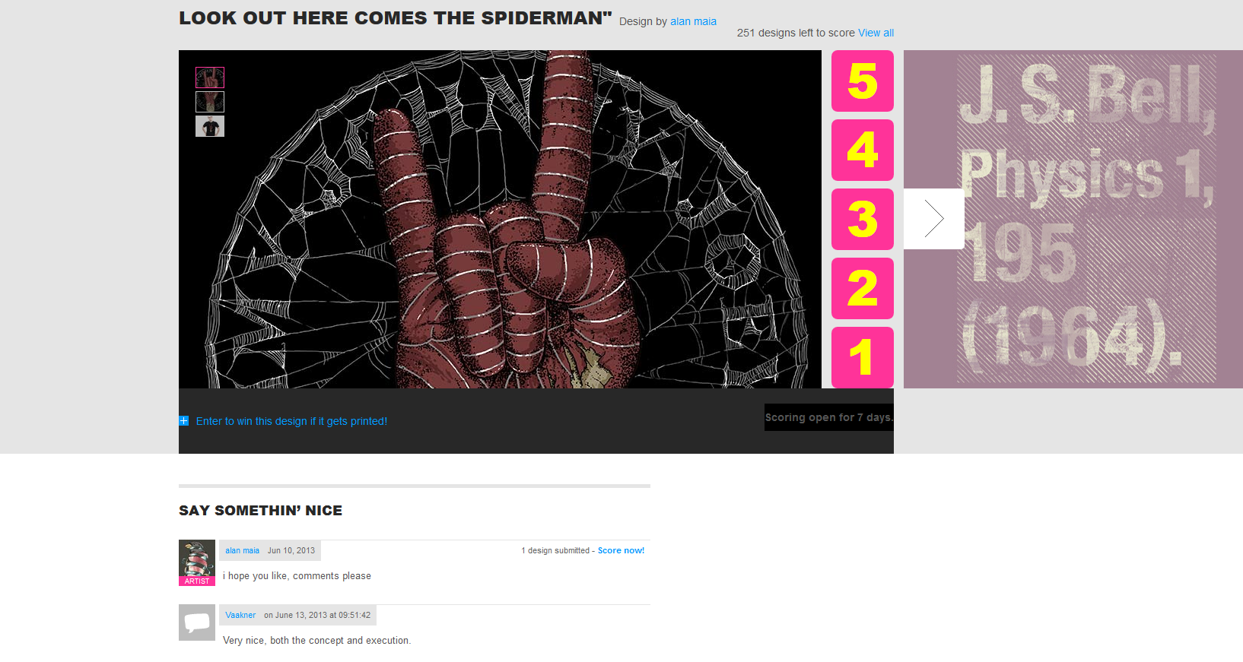

There is system in place to remove the designs that are doing the worst from scoring: if after first 24 h the score is below 1.7 the design is dropped from scoring. The designer has to agree to the legal terms and acknowledge he understands a design can be dropped from scoring early if it gets a low score. Threadless thus uses crowd to filter out poor quality designs. Other users are then encouraged to vote 4 or 5 if they like it and say $5 if they would like to buy it. (No need to buy, just getting an email if printed). User can always go back and change the score given to a design. Scoring page can be filtered by newest, oldest, average score and title. Aggregation is done by averaging scores.

**Scoring competitions**

To encourage scoring Threadless often organizes scoring competitions.

* *Score at least 80 spiderman designs and we’ll give $25 gift codes to 8 random scorers*
* *Help to choose winner for this challenge… Score at least 50 … designs and one random scorer will win $50 gift card*
* *Between 3.7.-7.7 score 25 designs daily and enter to win $250 gift card & art panel*
* *Score 50 Dangers… submissions by 9/11 for a change to win $75 in Threadless cash*
* *Score 50 Gap worn designs, snag $50. Post ones you absolutely love in comments below*
* *Score 50 dangers of the deep submissions by 9/11 for your change at $75 Threadless cash*
* *You are automatically entered when you score 50 designs so get to it!*
* *Score Fraggle Rock designs to win Fraggle Rock collector DVDs! Score 50 to enter*
* *Score 100 Trina Turk designs by 8/30 and one randomly selected scorer will get $100 Trina Turk + $100 Threadcash*
* *Score 60 of ‘em and you’ll automatically be entered into random drawing for $60 Threadcash*
* *Score 100 loves clever designs and one lucky scorer will receive a $100 gift code + Skype knock knock jokes*

Threadless encourages users to promote your design to friends, family and the rest of the internet! Post your design once it is up for voting. This will generate meaningful traffic & opportunity to vote when seen on Tumblr. There is no reason to promote one’s own work excessively, and self-promotion should be done with style: there are certain areas on the site where promotion is not considered ok, and some threads on the Forum specifically ban posting links to own designs. Calling all 1000 friends to vote designer’s own design is not against the rules of Threadless, but the people on the forums don’t like it. Community often notices large number of people voting one design and it isn’t looked upon positively. Work in progress blog posts on the other hand are considered a good way to promote designs. WIP threads are also a useful for getting quick answers on details like color.

* *Newbies: Post your own work and I swear I’ll comment something mean on it.*
* *The first thing to do is stop spamming everyone else’s submissions with links to your work. It’s not the done thing around here. Be nice. It’s like cold calling, nobody likes it*

**General promotion and funny competitions**

Threadless encourages general promotion of the site through funny competitions and suggestions to share site related content in social media.

* *Be a pal and like us as much as we like you!*
* *Share this challenge with the world*
* *Share this design to help it get printed*
* *Tell us why you love your mom and use the hashtag. We’ll pick 2 winners from each channel tomorrow 5 pm*
* *Repin your favorite pair of socks to win that pair! 8 pairs given away before Nov 22*
* *Get a brand new artist to submit a design to Threadless, and you could both score $2000*
* *Send 3 $5 gift cards to your friends to get one yourself*
* *Post a photo of tee to wear for your last day on earth with tag #Threadmageddon. 3 survival packs for winners*
* *Like & share the artist you like the best then enter to win their collection here*

**Downvoting**

Downvoting is when people vote low score on a design to increase their own change of getting printed. Downvoting is considered cheating by the Threadless community and designers find it annoying. Downvoting surfaces on the site occasionally, for example when a bunch of accounts is found, all of which have given average score of one. Downvoting often happens in combination with voting up one’s own designs, but downvoting is considered worse, because it affects the feedback from the community for the designer. It is believed the cheaters never win, because the ultimate printing decision is done by Threadless.

* *Cheaters never win and winners never cheat… or some shit like that*
* *There’s nooo waaaay that this got a legit 3.19 and all other scored below 3.0. Ur a cheating rat*
* *Commenting own designs using identities you use to downvote others is just LOW*
* *He can vote his up as much as he wants, but at least stop downvoting so I can gauge how shit my designs are*
* *Friends coming on to vote you $5 I don’t mind, but downvoting has to stop*
* *This (cheating) is truly awful… won’t print regardless how many friends vote and downvote. This sort of behavior ruins everyone’s enjoyment*
* *Yeah, downvoting good designs is a huge bummer*

**Selecting winners**

What scoring is enough to get my design printed? This question is probably in the mind of many Threadless designers. The answers found on the site are subjective. Anything above 3.0 is considered good but there are no guarantees because ultimately Threadless prints what they like/ think would sell, and only use scores as a guideline. A rough instruction for interpreting scores was presented on the Forum: 1.7-2.3 lowest, 2.3-2.6 medium, 2.6-3.0 medium-high, 3.0-4.0 high and 4+ legendary. The key to winning is making a good design, not getting the highest score. On the other hand Threadless states that “votes are so important to our decision in picking designs for printing we need more people voting.” Threadless doesn’t just decide what it prints from scores. Other factors probably include number of comments where less than 20 or more than 50 could be decent indicators of quality, and the checkbox “I’d buy it!” The scoring influences the Threadless staff, but they ultimately make the decision to print or not.

If an user thinks Threadless missed a design that should have been printed, the user can tell them to #printit:

* *Show us another artist’s design on Twitter, Tumblr, or Pinterest with hashtag #printit*
* *We’ll be checking the hashtag from here on*
* *We’ll print at least 6 overlooked designs between now and Feb 28*
* *The design you #printit should be other designer’s. You don’t have to have scored it to post it*

### Tasks

Threadless often features scoring challenges to encourage people to vote on designs. Typical format is to select a $25-$50 gift code winner randomly among people who score 50-100 designs in certain challenge before a certain deadline. A variation is to challenge people to score certain number of designs every day for a week.

* *Score 50 Threadless + Gap worn-in designs*
* *Score 100 Loves clever designs*
* *Score 50 loves photography submissions by June 15 for your change at $50 gift code*
* *Score 60 path submissions for $60 Threadcash!*
* *Score 25 designs every day for a week and win $250 Threadless stuff*

Some people in the Threadless Forum score all the designs that go up for voting as a personal challenge.

* *1132 designs! Challenge accepted.*
* *500 of 1158 scored*
* *It’s insane there are people that score every design that goes up!*

Designers often ask people to score their designs on the Threadless Forum:

* *Here is my first submitted design. Hope you like it and vote for it =)*
* *Could you please score my design if you have the time, thanks <link>*
* *I love it!!! Very nice!! 5 Would you vote the mine???? <link>*
* *Woop! My critique is now subbed:D could use votes now :P*
* *Would you be kind enough to vote please? <link>*
* *Vote vote vote! I’m voting on the ones here too*
* *This one is in it’s last day and need some love to keep it above 2.52 (a good score for me)*
* *Need votes, need votes, need votes, need votes, need votes, need votes, need votes, need votes, need votes, need votes, need votes, need votes, need votes, need votes, need votes, need votes, need votes, need votes, need votes, need votes, need votes, need votes, need votes, need votes, need votes, need votes, need votes, need votes, need votes, need votes, need votes, need votes, need votes, need votes, need votes, need votes, need votes, need votes, need votes, need votes, need votes…*

The Threadless platform also suggests scoring designs every now and then. For example if users on the platform have their own designs submitted the platform suggests I score them, with a link.

* *2 designs submitted – Score now!*
* *Score designs to help pick the winner!*
* *Go score and support!*

In addition to scoring there are some other opportunities to participate in decision making at Threadless:

* *Think we missed a design? Tell us to #printit! Show us another artist’s design with hashtag. Go to <link> and filter by designs you’ve scored 4 or 5.*
* *Help us decide which artist will get made. Enter to win by like & sharing the artist*
* *Help us pick the next design challenge. In comments write theme in bold then sentence or two of copy.*

### User experience

**Scoring designs**

Scoring designs is a major part of what a user can do on the website, in addition to surfing the Forum. Scoring designs is easy and fun, and somehow the most obvious thing to do. Scoring is also the easiest way to get something done if I cannot figure out anything else to do. Usually I score in one design mode and with default settings. Most designs are of decent quality and some are just awesome.

* *Trying to score some designs. Wonder what do I get out of this? Wow, two methods of scoring. Automatically shows different views of design (in single mode) I don’t like this other approach that much. Pics small, number on the way*
* *I haven’t seen instructions on voting. Actually I have! Hidden in buttons scale: Ugh, Meh, OK, YAY!, $!!!*
* *Scoring designs, it’s late. Oxymorons, a challenge I haven’t seen before.*
* *Scoring some designs. Newest. What ever happened to be first by default. Scored 50*
* *Scoring, newest Threadless. There’s always new content, other categories tend to be empty*
* *Scoring, Awkward challenge. Scored all 3. Haven’t found easy way to get back to scoring page after finishing*
* *Scoring designs, Odd couples. 253 (?) left, open for 6 days. Enter to win if printed .Win this design actually nice prize for participating, entering a couple of competitions*
* *I guess I was worried for nothing when I thought I may run out of designs to score…*
* *Cool retro super Mario <# princess shirt. (After participating to lottery on a t-shirt?) Threadless asks to promote the design to my network: “Be a pal…” Example of exploiting the need for reciprocity?*

**Scoring modes**

Most of the time I prefer the single design mode in scoring designs, which makes it easy to get in a flow for a while when scoring designs. Platform always gives me a new one after scoring automatically. It is somewhat tempting: so easy to score one more. I’m always waiting for the next (rare) really good one. I still wish it loaded some designs on my computer in advance. There’s always a lag between scoring a design and getting a new one. I only use the many design scoring mode when the connection is slow. Threadless challenge is my favorite to score. There’s always new content. Occasionally I enter to contest to win the t-shirt if it is particularly nice.

* *Scoring in many design mode. Faster on slow connection. Threadless, newest first*
* *Picking designs on mobile. Slow!!! Scored 1 design, I think. Slow and frustrating, impossible to use for scoring. App crashed.*
* *This scoring is fun. I want to do more, but definitely in single design view*

**Flow**

I find scoring to be a somewhat pleasant activity, and even inducing mild flow in single-design mode. The flow experience seems to be related to appearance of new tasks at suitable rate and expectation of somewhat rare awesome designs. Scoring is the easiest thing to do something useful at Threadless.

* *Scoring is still somewhat flow-inducing. Especially today, when quality seems to be particularly good.*
* *I’m always waiting for the next (rare) really good one*
* *Scoring. Threadless, filtered by avg. score for change. I want to see good stuff this time. Not that the content usually was bad, but I want to see some 5 worth designs*
* *It’s easy to get in a flow for a while when scoring designs. The platform should be faster, still. Time wasted between loading*
* *I think what keeps me going is expectation of seeing a great design every now and then… worth 5 could be next…*
* *Scoring designs. Very easy “at least I’m doing something” option if I can’t figure out anything else to do*
* *Scoring designs. What else would I do? Feeling tired, but this task is still easy*

**Boring**

After around hundred or so designs the scoring starts to get boring, especially if all the designs are from the same challenge. Randomization might help to alleviate this issue by adding more variety.

* *Alright, got bored. The quality also seemed to be going down. The crowd probably can have a good guess on design quality*
* *I would like randomization, all contests in one jumbled-up pool => greatly alleviate the fatique of scoring 500 designs of Fraggle Rock. Made you vote for longer periods*
* *Especially with B&W contest it gets tiresome to look trough 100 entries at a time*
* *I do like cat tees, but I was scoring those and it seemed like they would never finish with some kind of infinet loop of feline apparel.*
* *I would like to keep option of not mixing challenges to avoid a challenge I have no interest in*

**Scoring challenges**

I participate in scoring challenges when I see one, but they don’t change my behavior much. During my observation period I would be scoring designs anyway, but the contest may direct me to challenges I would otherwise ignore.

* *“Score 25 daily, win $250”. Will do this! Scoring, newest Threadless. 34 left, should I score only 25? Scored ‘em all anyway, many good designs today*
* *LOL been scoring like crazy last few days didn’t realize it was starting Monday LOL its all good always scoring anyway*
* *I’ve scored em all. That little “You’ve scored X out of Y” ticker excited a gotta-catch-em-all sort of neurosis*
* *It’s insane there are people that score every design that goes up!*
* *Yeah, those people must have no lives <cough> … one of those people*

**Accuracy**

I have a feeling that the accuracy of my evaluations varies a lot. I’m also a critical evaluator, but I guess there’s nothing wrong as long as the opinion is honest.

* *Scoring to get something done. Super cats, newest. I believe my evaluation accuracy varies wildly. Feels like I’m constantly adjusting what needed for certain score*
* *Scoring designs. I’m a critical scorer: mostly 3,2,1, occasional 4, rare 5. I’m not evaluating goodness but would I wear => tough scale*
* *I feel like giving lots of 1s, some of them undeserved*
* *I’m giving automatically high scores for tees featuring zombies. Zombies somehow feel like a Threadless thing*
* *I don’t rate solely on whether I would wear it or not. Artwork well , I vote well*
* *Even though I subbed in the challenge I didn’t feel bad voting 1 on 90 % subs. It was 100% honest opinion*

**Waiting for scores**

Waiting for results of scoring can be a nerve-wrecking experience for designers.

* *It’s a scary thing waiting for scores… I suppose it’s a good thing that you don’t know until the end, keeps you on the edge! ;)*
* *Soo much anxiety!*
* *Nail biting stuff, I’ve got a design up and I’m bricking it. Even if I fail I’ll keep coming back and trying again, I love this place*
* *I think everyone is nervous during the voting period, haha! Especially when it’s in a contest that will last 30 more days! :P*
* *One day to go on mine, I am very nervous, haha.*
* *Just like what you feel right now we are all nervous ^_^*
* *Glad It’s not just me! My first 2 went up and I’m on pins and needles. It might be good thing we can’t see scores before it’s over. I would be checking them constantly…*
* *My first design is also up for scoring and I’m crazy anxious about what scores its getting*

**Number of scores**

Typical number of scores for a design appears to be a few hundred, according to some users’ experiences. There’s some suspicion on fairness of exposure depending on when the design was posted in the challenge.

* *I’m wondering how many votes it usually gets? Or does that even matter?*
* *I’ve just submitted my first design and I’ve currently had 139 people rate it*
* *We barely got 300 votes when the regular Threadless contest nets 500-800 on average now*
* *300 to 400 seems to be normal for me at the moment (number of votes)*
* *After 7 months this is what I feel: No matter if you get 500 or 1000, it’s just a sample, and final score won’t be that different*
* *A ratio of 1 comment to 10 votes is a sign of a decent score these days, I think*
* *Voting incentives can really screw people over with the current system. Older can have 300, new 1000*
* *I feel like entries submitted later have more thought and effort => giving more visibility to ones submitted early seems to hurt quality*
* *I’d rather see all subs getting the same exposure*

**Scores as feedback**

Scores provide feedback to designers. Good scores may rise the hopes of getting printed, while low scores can feel crushing, especially if possible cheating or downvoting is involved in the challenge.

* *As a design community, it’s cool to see how acceptable your design was, and most of that is given by the score*
* *Threadless community tend to like certain things more than others. Scoring isn’t random. Older members have accurate sense whether design will do well*
* *I got a score of 3.98. I just wanna know why my design wasn’t printed… I’ll just keep on submitting till I get printed*
* *I’ve just submitted my first design and was wondering what sort of score you need for it to get printed?*
* *Key to winning is making good design, not getting the highest score*
* *It is very disheartening to see your design finish with so many ones*
* *Page 8 and dropping. Ok no it’s not funny. Get feedback on WIP. Submit. No comments, drop to last page. Crawl under a rock*
* *One of the main reasons I stop being assiduous Threadless member are this faking new users that not only cheat but downvote everything*
* *Then I remember how I don’t care about the scores anymore!*

**Cheating and downvoting**

There is evidence of occasional cheating and downvoting on Threadless. In these cases a user may create multiple accounts to give his designs high scores and everyone else low scores, effectively determining the results of scoring. This is very annoying for other participants, especially because it ruins the feedback from community. There’s a common belief that the cheaters will not win, because the final decision on what to print is made by Threadless.

* *Despite shirt being in top 10 I think It scored kinda low :/ Anyone else experiencing this with B&W contest?*
* *Don’t worry, most challenges score that way these days, and most of us experience it, yet staff will pick what they think is good, regardless of low scores and truckloads of ones*
* *Out of nearly 1000 subs there was one that scored above 3… and it didn’t deserve that in my opinion. So yeah, rampant downvoting*
* *I know scores are arbitrary, but this makes a bit of a mockery of the system, and I never really remember this happening on the old site*
* *Downvoters were out in droves for the B&W challenge, I got 339 ones on my submission*
* *Suddenly there were 100+ votes without single comment and that’s always a bad sign*
* *864 votes of 1.00, time well spent… Word fail me. And that’s just one identity!*
* *Jojo40 has scored 398 submissions, giving an average score of 1.00*
* *Multiplicity of challenges (big brands) are bringing in new voters & contenders who don’t give a shit about design, fairness, etc. but are quite effective at networking => affects score more and more*
* *It is unfortunately common. Good news is that cheaters don’t win.*
* *I’m really angry about this… People sharing opinions, critiques, trying to help improve others, but there is always a few rotten apples that spoil the fun*
* *Downvoters are the biggest issue - this is what may render final score inaccurate*
* *… what’s more important it is acting like discouragement (downvoting)*
* *Downvoting good designs is a huge bummer*
* *He can vote his up as much as he wants but at least stop downvoting so I can gauge how shit my designs are*
* *This irks me. Not because I think his attempts to circumnavigate legitimate voting will end successfully but because it does make an absolute mockery of the system*
* *I would really love someone from Threadless to comment on this, instead of remaining silent as usual…*
* *2.72 is part of a 300-way tie for 6th place :) My guess: cause is people entering score 100 -competition and just rating all the same*

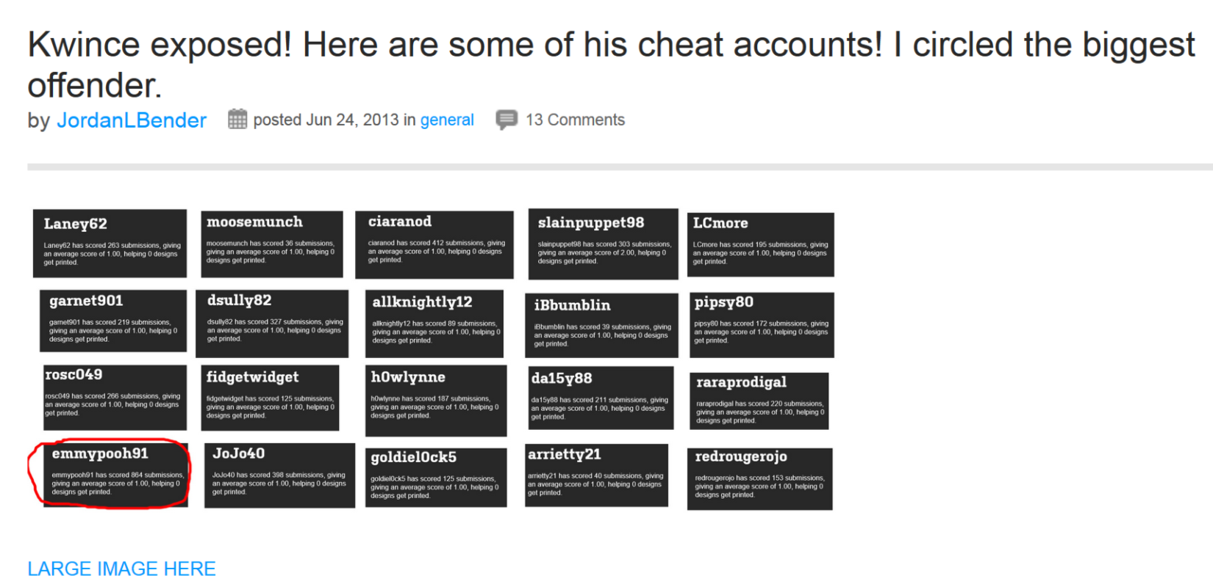

Another form of cheating is copying or stealing other people’s designs.

* *Threadless admin, someone is submitting my designs. Could you please ban this fucker as all his/her submissions are actually my designs*

**Promoting designs**

Opinion on promoting designs in scoring is split within the community. Although approved by Threadless, some people are still against it, at least in extreme forms. The main complaint is biasing the scoring.

* *In principle I’m against people calling their followers to vote on the design*
* *Threadless is not against this practice, but it makes competition really stupid. [It] becomes a competition about how many friends you have*
* *I agree, asking friends to vote and give you 5$ is pretty much the same as making new accounts and voting multiple times*
* *I’m glad that FB/Twitter promotion isn’t requirement here. Etzy etc. want/need people to do that so it’s an automatic reaction to some*
* *My design (that I didn’t advertise) got 684 votes. Yours got 1850 votes. You overpowered Threadless community opinion by more than 100 %*
* *You can easily overthrow the opinion of Threadless community with your own voters. This is what seems problematic to me.*
* *I’m worried about sudden, discontinuous changes in the judging of designs*
* *You shouldn’t underestimate the role the final score plays in determining what gets printed. Many printed designs are highest scoring designs*
* *I think there are properties of good competition that Threadless might lack, or at least, not enforce. I want a system that allows for the best competition*

On the other hand people are also defending promotion as a way to engage with fans and bring new people to the site.

* *Unfair to other designers? I have worked hard to build and maintain that fan base. Trying to make career from my art for 15 years*
* *I just don’t agree with “don’t promote”. Seems counterintuitive*
* *Asking people to come and vote for a specific shirt doesn’t hurt anyone else’s changes of getting printed. No direct competition*
* *Ultimately the decision is up to Threadless, so a ton of outside votes doesn’t really upset anything*
* *If Threadless wanted to create the system you describe, they would limit the voting community and only allow people who purchased shirts*
* *It still seems illogical to me not to promote my design on my fan page. Fans, not friends. They vote because they like & want to buy art*
* *Added bonus of bringing in new people to Threadless community. Seems like a good, positive thing*

## Prizes

### Rules

Designers whose designs get printed at Threadless get typically around $2000 cash and $500 gift code. Special challenges offer also extra items, such as tickets to events, gift cards to other stores, baseball bats, or higher amount of cash, such as $3000 or $5000. The understanding in community seems to be that the focus of designers should not be on winning, which is rare, but on making stuff and enjoying it.

* *Just make and enjoy*
* *Don’t focus on getting printed, just make stuff and enjoy it. High scores are nice but don’t equate to a print*
* *If you win you’ll get, $2000 cash, $500 Threadless gift code, $200 Onion store code, 2 VIP passes, Framed front page with photo, Onion library*
* *Other designs chosen for print from this challenge will receive compensation based on the product printed on & the quantity printed*
* *One lucky designer will receive $5000 in cash*

### Tasks

Check out the prizing and submit at the challenge page.